PROJECT 1:UnderstandingSoftware Development LifeCycle And Testing Types
Tasks:
Research and document the phases of SDLC (e.g.,Requirement,Design,Implementation, Testing, Deployment, Maintenance).
- Introduction
- SDLC (Software Development Life Cycle) is a systematic process used by software development teams to plan, develop, test, deploy, and maintain software applications.
- The main purpose of SDLC is to develop high-quality software within the required time and budget while satisfying user and business requirements.
- SDLC generally consists of the following phases:
- Requirement Analysis
2.System Design
3.Implementation
4.Testing
5.Deployment
6.Maintenance
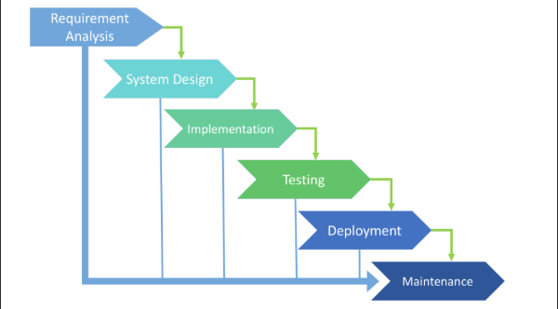
1. Requirement Analysis
- Requirement Analysis is the first phase of SDLC. In this phase, the development team identifies and understands what the customer or users expect from the software.
- Activities:
- Collect requirements from users.
- Understand business needs.
- Identify functional requirements.
- Identify non-functional requirements.
- Analyze the feasibility of the project.
- Prepare the Software Requirement Specification (SRS).
- Example
For an Online Examination System, requirements may include:
- Student registration and login.
- Teacher login.
- Online examination.
- Multiple-choice questions.
- Automatic result calculation.
- Result viewing.
2. System Design
- In the Design phase, the requirements collected in the previous phase are converted into a technical design for the software.
- Activities
- Design system architecture.
- Design database.
- Design user interface.
- Define modules.
- Select programming languages and technologies.
- Design data flow and system components.

Student
↓
Login
↓
Exam
↓
Submit Answers
↓
Calculate Result
↓
Display Result

3. Implementation
- Implementation is the phase where developers convert the design into actual source code.
- Activities
- Write program code.
- Create database tables.
- Develop different modules.
- Integrate required components.
- Perform initial unit testing.
Example
For an Online Examination System, developers may use:
- Java for backend programming
- JSP/HTML/CSS for the interface
- MySQL for the database
- Tomcat as the application server
4. Testing
- Testing is the process of checking the software to identify defects and verify that it satisfies the specified requirements.
- Testing helps ensure that the application is reliable, functional, secure, and usable.
- Major Testing Types
Unit Testing:
- Tests individual functions or modules.
Integration Testing:
- Checks whether different modules work correctly together.
System Testing:
- Tests the complete application.
Acceptance Testing:
- Checks whether the software meets customer/user requirements.
Smoke Testing:
- Checks whether the important basic functions of a new build are working.
Sanity Testing:
- Checks a specific functionality after a small change or bug fix.
Regression Testing:
- Ensures that new changes have not affected existing functionality.
Performance Testing:
- Checks response time, speed, stability, and behavior under workload.
Security Testing:
- Checks whether the application and its data are protected from security vulnerabilities.
5. Deployment
Deployment is the process of releasing the tested software to the production environment so that actual users can use it.
Install the application on the production server.
Activities:
- Configure the database and server.
- Deploy the application.
- Perform final checks.
- Make the application available to users.
Example
After testing an Online Examination System, it can be deployed on a web server so students and teachers can access it through a browser.
6. Maintenance
- Maintenance is the final phase of SDLC. It begins after the software has been deployed.
- The software is monitored and updated according to user requirements and changing business needs.
Types of Maintenance
- Corrective Maintenance – Fixes errors and bugs.
- Adaptive Maintenance – Modifies software for a new environment or technology.
- Perfective Maintenance – Improves existing features or adds new features.
- Preventive Maintenance – Makes changes to reduce the possibility of future problems.
Example
If users report that the result page of an Online Examination System is not displaying correctly, developers fix the issue and release an update.

